Dataset analysis

1. Dataset Size and type

* 15120 samples
* 55 dimensions

1-10 dimensions: continuous values

11-54 dimensions: binary values

55th dimension: forest cover type (total 7 types)

1. Statistical description

This part statistically analyses mean, standard deviation, min, max etc. of each feature.

Here list analysis of first three features.

          Elevation        Aspect         Slope

Count 15120.000000 15120.000000  15120.000000

mean    2749.322553    156.676653     16.501587

std      417.678187    110.085801      8.453927

min     1863.000000      0.000000      0.000000

25%     2376.000000     65.000000     10.000000

50%     2752.000000    126.000000     15.000000

75%     3104.000000    261.000000     22.000000

max     3849.000000    360.000000     52.000000

1. Skewness

Skewness measure how asymmetric the distribution can be.

* Values close to 0 show less skew
* some algorithms may benefit if large skew is corrected

Eg. Skewness of 1st to 5th feature in our dataset

Elevation                               0.075640

Aspect                                  0.450935

Slope                            0.523658

Horizontal_Distance_To_Hydrology      1.488052

Vertical_Distance_To_Hydrology          1.537776

1. Class distribution

Check number of instances belonging to each class.

In this dataset:

Cover_Type # of instances

1    2160

2    2160

3    2160

4    2160

5    2160

6    2160

7    2160

1. Correlation between two features

Below list high correlated pairs (threshold 0.5):

Feature 1 Feature 2 Correlation score

Hillshade_9am Hillshade_3pm -0.78

Horizontal_Distance_To_Hydrology Vertical_Distance_To_Hydrology 0.65

Aspect Hillshade_3pm 0.64

Hillshade_Noon Hillshade_3pm 0.61

Slope Hillshade_Noon -0.61

Aspect Hillshade_9am -0.59

Elevation Horizontal_Distance_To_Roadways 0.58

The high correlated features can be further processed to decrease the number of dimensions. Thus decrease the complexity of the model.

1. Scatter

Plot highly correlated pairs. Below are scatters of two examples from our dataset.

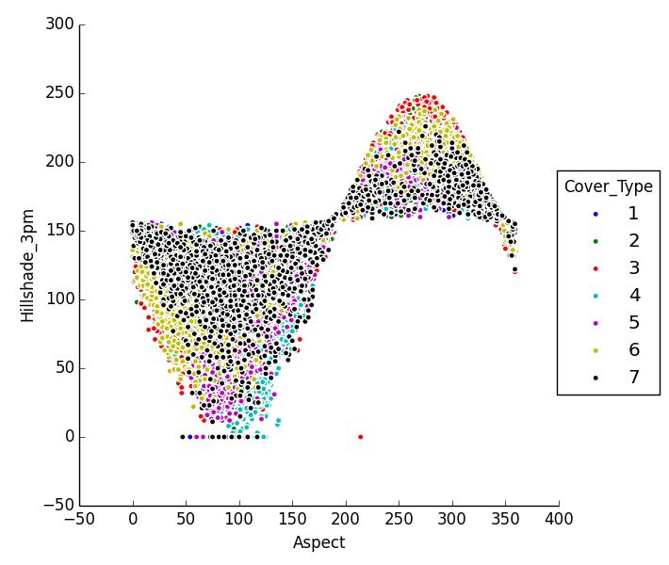

Figure 1 relation between Hillshade_3pm and Aspect

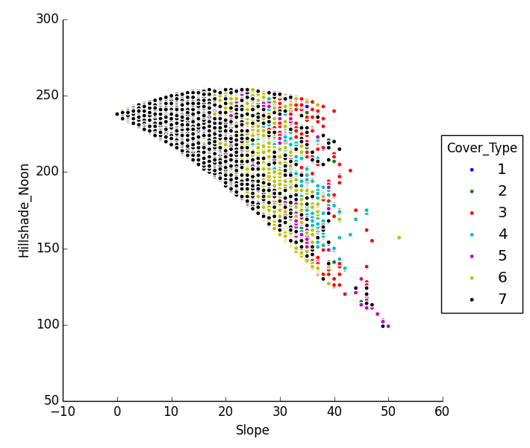

Figure 2 Relation between Hillshade_Noon and Slope

It can be seen from the figure 1 that cover type No.7 scattered around 150 Hillshade_3pm. Other features scattered far away from 150 Hillshaed_3pm. When the aspect is less than 200, all cover types are less than 150 Hillshade_3pm and vice versa. In figure 2, when the slope is low, it is more likely to be cover type 1. With the increasing of the slope, cover type changes to type 6 and then other types.